**ASSIGNMENT 02 FRONT SHEET**

|  |  |  |  |
| --- | --- | --- | --- |
| **Qualification** | **BTEC Level 5 HND Diploma in Computing** | | |
| **Unit number and title** | Unit 09: Software Development Life Cycle | | |
| **Submission date** | 04/07/2022 | **Date Received 1st submission** |  |
| **Re-submission Date** |  | **Date Received 2nd submission** |  |
| **Student Name** | Bùi Hương Linh | **Student ID** | GBH200662 |
| **Class** | GCH1002 | **Assessor name** | Đỗ Tiến Thành |
| **Student declaration**  I certify that the assignment submission is entirely my own work and I fully understand the consequences of plagiarism. I understand that making a false declaration is a form of malpractice. | | | |
|  |  | **Student’s signature** |  |

**Grading grid**

|  |  |  |  |  |  |  |  |  |
| --- | --- | --- | --- | --- | --- | --- | --- | --- |
| P5 | P6 | P7 | M3 | M4 | M5 | M6 | D3 | D4 |
|  |  |  |  |  |  |  |  |  |

|  |  |  |
| --- | --- | --- |
| **❒ Summative Feedback: ❒ Resubmission Feedback:** | | |
| **Grade:** | **Assessor Signature:** | **Date:** |
| **Internal Verifier’s Comments:** | | |
| **Signature & Date:** | | |

# Introduction

Tune Source has approved the project of creating a new website for this job. This study outlines some of the final steps in bringing the project to market. To begin, we must define the case study's stakeholders, their roles, and their interests... This report will go over and demonstrate how to implement a software development life cycle as well as the appropriateness of software behavior design techniques when working on the TuneSource Project.

# Task 1 – Analysis (1)

1. Identify the stakeholders, theirs roles and interests in the case study.
2. Requirement

In software engineering, a requirement is a feature of new software that someone wants, needs, or commands. It describes the software's capabilities and any limitations it should have.

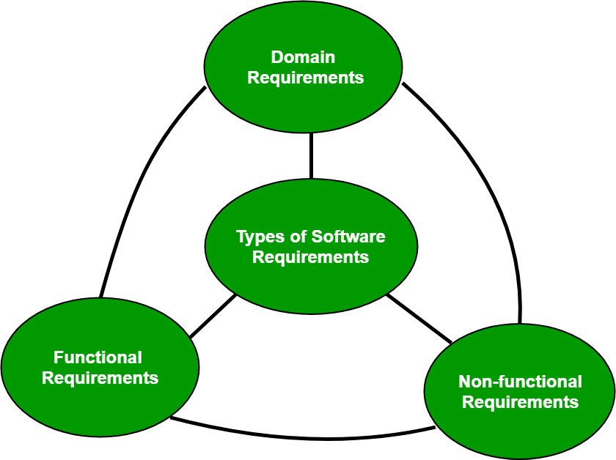

Figure 1: Requirement (Source: Internet)

1. Stakeholder and their interest

|  |  |  |  |
| --- | --- | --- | --- |
| No | Stakeholder | Role | Interest |
|  | Bui Huong Linh | Project Manager | The project manager is involved in the planning, execution, supervision, control,... |
| 2 | User | Customer | Make purchases on the website, the downloads, users increase, revenue increases to help the company grow more. Give feedback for website development. |
| 3 | The IT department | Website administration | Receive a salary from the company |
| 4 | Bui Huong Linh | Project Manager |  |

1. Discuss the relationships between the FRs and NFRs.

|  |  |  |  |
| --- | --- | --- | --- |
| No | Requirement | Type of requirement | Explain |
|  |  |  |  |
|  |  |  |  |
|  |  |  |  |
|  |  |  |  |
|  |  |  |  |
|  |  |  |  |
|  |  |  |  |
|  |  |  |  |
|  |  |  |  |
|  |  |  |  |

# Task 2 – Analysis (2)

1. Use case

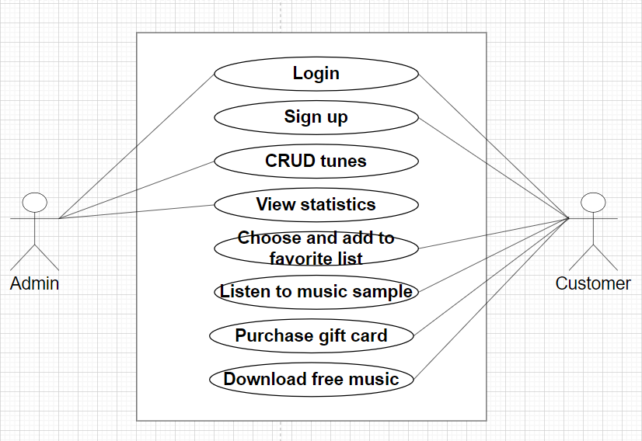

* Admin can login and view, add, edit, and delete tracks, as well as view statistical data.
* Customers can login, listen to music samples, choose and add to favorites list, ...

1. Use case description for 2 case
2. Context diagram
3. Data flow diagram level 1
4. ERD
5. Flowchart of Tune Source system
6. OOP techniques: Class diagram àn Activity ( ai lm M)

# Task 3 – Analysis (3)

1. Discuss how the user and software requirements are addressed in the design phase.
2. Flowchart
3. Source code
4. Test case

|  |  |  |  |  |  |  |
| --- | --- | --- | --- | --- | --- | --- |
| Test | Test Description | Test Steps | Test Data | Expected Results | Actual Results | Pass/Fall |
| 1 | Register | 1/ Enter  2/ Login | Email: 1  Password: *  Re-Password: * | Successfully registered an account. | Successfull | Pass |
| 2 | Login | 1/ Register  2/ Login | Email: 1  Password: * | Successfully logged into the account. | Successfull | Pass |